RIVER LEN LOCAL NATURE RESERVE
MAIDSTONE

HABITAT MANAGEMENT PLAN
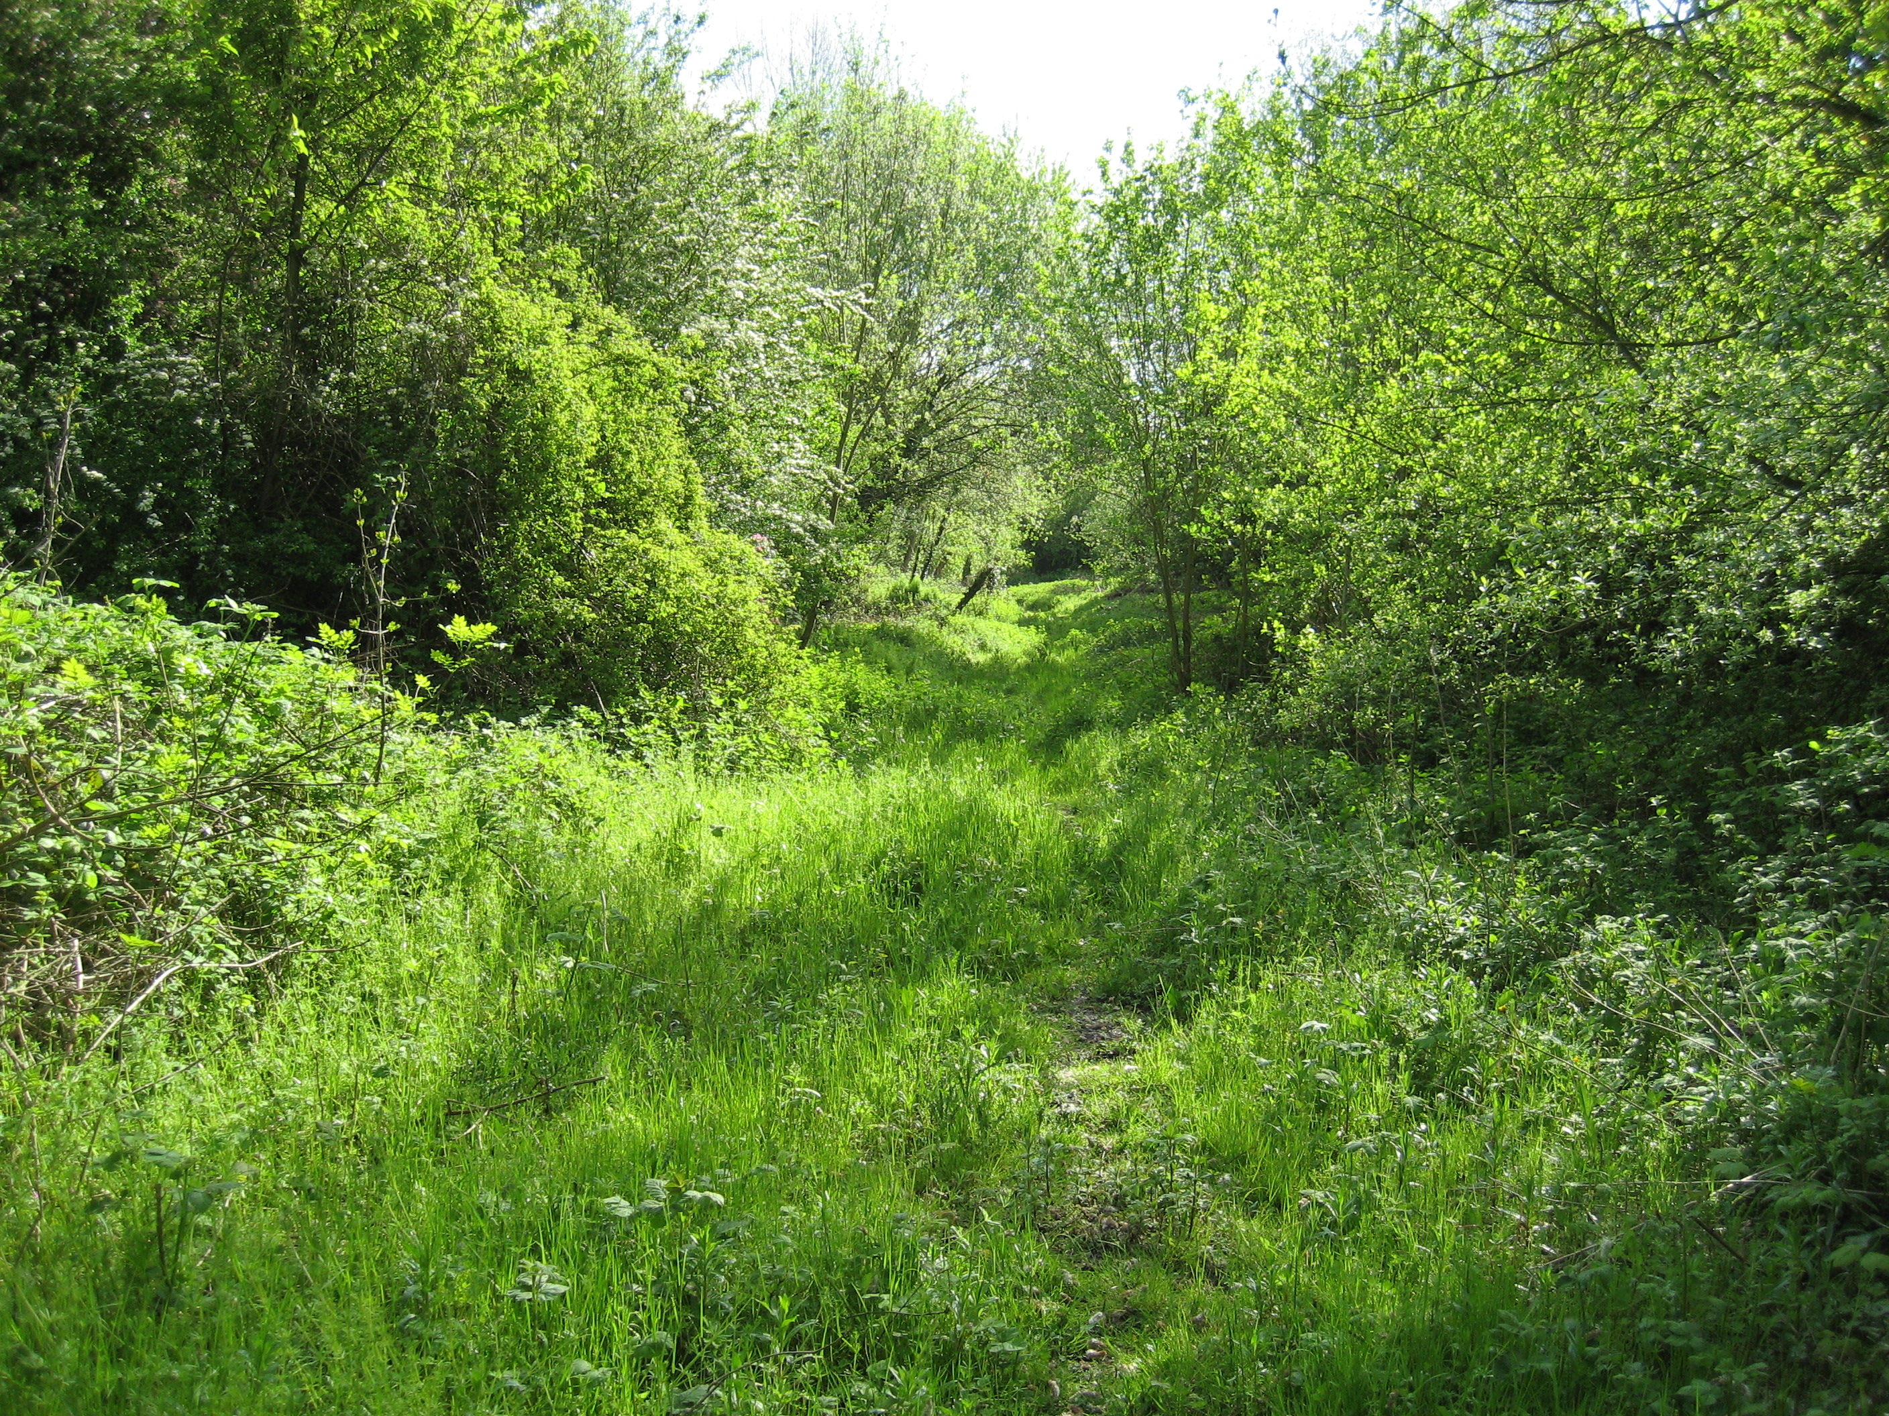
2012 - 2022
Foreword: A 2.54 hectare inner-urban site owned by Maidstone Borough Council and managed for the benefit of nature conservation, the quality of life of local residents, townscape, flood water storage, air quality. The reserve forms a part of the Mote Park and River Len Local Wildlife Site (MA62) and is designated as a Local Nature Reserve. The River Len is classified as a Critical Ordinary Watercourse by the Environment Agency. It is bounded to the North by Riverbank Close and the Sunningdale Court tower block, to the west by the Sainsbury car park, to the east by Turkey Mill, to the south by back gardens of properties in Chancery Lane, Mote Road, Square Hill Road, Blythe Road, allotment gardens and Mote Park. In addition to the sites own intrinsic landscape and amenity value it also provides a significant wildlife habitat on a County-wide scale and green corridor link between the town centre and the historic Turkey Mill, Mote Park and open countryside to the east.

Introduction: For the purposes of this habitat management plan the nature reserve has been sub-divided into compartments, each comprising a specific area and habitat type.

Prescriptions have been drawn up with continuity of established habitat types in mind. These comprise open water habitats, woodland, species rich damp grassland with spring-line seepages, scrub and diverse wetland habitats including the sedge and reed-mace lined river channel and crack willow / alder carr.

Survey work on the site has identified a rich saproxylic (species with life-cycles reliant upon dead wood) invertebrate fauna that is particularly associated with wet woodland. The relationship between woodland and water and the requirement to retain both standing and fallen dead wood thus informs the management prescriptions set out in this document.

A further source of considerable invertebrate interest is the reed-bed and damp grassland that persists at the Southwest extent of the site – but that is particularly threatened by aggressive garden escapes such as Himalayan giant blackberry and sycamore. Invertebrate species recorded here that are particularly associated with this habitat include Desmoulin’s whorl snail Vertigo moulinsiana and water vole Arvicola terrestris, both legally protected UK and Kent Biodiversity Action Plan Priority Species, the crane fly Tipula maxima, white-legged damselfly Platycnemis pennipes, large red damselfly Pyrrhosoma nymphula, banded demoiselle Calopteryx splendens short-winged conehead cricket Conocephalus dorsalis and the soldier beetle Silis ruficolis. Landlocked urban colonies of grassland butterflies including gatekeeper, orange tip, small copper, meadow brown, common blue, Essex and large skipper also persist at this site.

An aspiration of the management / planning committee is an incremental expansion in the extent of the Len Valley Local Nature Reserve. This would help achieve sympathetic wildlife and landscape management of the wider River Len catchment and the creation of a wildlife corridor through urban Maidstone and the adjoining farmed landscape.

General Management Prescriptions:

Initial major management tasks such as the felling of large sycamores and removal of invasive plant species were carried out by contractors. Subsequent management work has involved local amenity groups and community volunteers.

Perimeter fences and gates at the Square Hill Road frontage to be secured and maintained.

Following intensive rubbish clearance on the site and within the river channel the site is monitored on a day-to-day basis and new incidences removed as they occur.

Chemical herbicide treatments will not be utilised on site.

No bonfires to be utilised within site, to avoid accidental or deliberate destruction of important dead wood habitats, damage to sensitive ground flora, nutrient enrichment of soil and nuisance to neighbours.

Damaged signage including 'no fishing' signs will be repaired or replaced as necessary.

Surveys of flora and fauna and observation of species population dynamics will be ongoing with the site species list updated as required. Data from surveys and observations will inform the evolution of the site management plan.

Community Involvement and Educational Use:

The proximity of the Len Valley Local Nature Reserve to a large urban population means there is great potential for local people to become involved in the management of the site and to increase use for educational purposes.

A key target in the development of the site is the involvement of the local community. Already there is a good deal of interest and support in such activities as rubbish clearance and hedgerow maintenance and this will be further encouraged over coming years

Specific Targets:

To hold educational events with local schools, families and youth groups with a target of two events each year. Highlight the importance of the site to local schools.

Hold at least one public event each year to attract new users to the site and to highlight the importance of the site.

Involve volunteers and the local community in practical events where it is appropriate and safe to do so.

Maintain a high public profile for the site through the local press and other relevant publications (this approach was particularly successful during 2007/8)

Specific Management Prescriptions:

1. Area of damp neutral grassland on the Southern bank of the River Len from the Sainsbury car park eastwards towards the area of secondary woodland flanking Square Hill Road. Please note that this sensitive area has a strict restricted public access policy (reflecting wildlife habitat mitigation role arising from historic planning commitments) to prevent disturbance and damage.

The key management intervention will comprise a November mechanical clearance of encroaching bramble on either side of the ride that bisects this compartment, to a depth of two metres, to retain a complex vegetation structure. Resulting cuttings should be piled-up in half shade well away from seepages and within already nutrient-enriched areas of reserve, dominated by nettles. Sapling trees should be hand pulled with larger specimens felled where they encroach upon ride and its scrub fringes. Where possible, timber resulting from removal of encroaching sycamore and Ash should be retained in large pieces in partial shade on the periphery of the grassland.

Trees adjacent to the south bank of the River Len and Wat Tyler Way fly-over will be monitored annually by the Management Committee and ring-barked, felled or thinned, as necessary, to ensure maintenance of a complex vegetation structure allow extra light into the adjacent reed-bed (which supports legally protected populations of water vole Arvicola terrestris and Desmoulin’s whorl snail Vertigo moulinsiana). Timber arising from arboriculture work within the reserve and within surrounding areas will be retained on site in partial shade to provide a habitat for saproxylic organisms.

Tins and felts are distributed along the ride feature within this compartment to facilitate monitoring of a significant resident slow-worm Anguis fragilis population. Regular sensitive monitoring and recording of population dynamics for this legally protected reptile species informs fine-tuning of site management interventions.

The shallow water-filled scrape excavated at the western extent of the ride should be monitored, de-silted and extended as required (in November) to maintain an area of open water. This shallow scrape attracts a significant assemblage of aquatic invertebrates and vertebrates including large red damsel-fly Pyrrhosoma nymphula , palmate newt Triturus helveticus and breeding common frog Rana temporaria.

Kent County Council should ensure ongoing repairs to barrier fencing beneath the Wat Tyler Way fly-over to prevent unauthorised access to the void beneath the structure. In co-operation with Kent Bat Group and Kent Highways Services there exists an aspiration to introduce bat boxes or baffles under the fly-over structure to accommodate bats roosts and hibernation sites.
2. Area of woodland on the southern bank of the River Len west of Square Hill Road.

Regenerating sycamore to be maintained on a frequent coppice regime (every three years). A management regime which will allow the continued survival of fungi and invertebrate species reliant upon the trees – many of which provide an important food source for mycophagous and predatory species including beetles, wasps, bats and birds. An annual assessment will be made on the need to fell, ring-bark or thin further trees to ensure retention of a complex vegetation structure and a good diversity of light and shade conditions. As a general rule, felled trees should remain intact where they fall. Trees that need to be moved for access and safety reasons should be retained in large pieces and stacked in partial shade. All sycamore seedlings visible within open areas should be hand-pulled to prevent further colonisation of this species.

Following major tree felling works in the winter of 2002-2003 in this compartment regeneration of native trees such as ash, silver birch, wild cherry and hazel has been prolific. In addition, invertebrate populations dependent upon dead wood habitats, such as wasp beetle Clytus arietus, longhorn beetle Strangalia maculata and fungus weevils Anthribidae sp. are flourishing and are observed in large numbers within woodpiles and feeding at flowering hogweed, ragwort and hawthorn.

A central clearing will be maintained within this zone to provide a sunlit yet sheltered habitat to encourage a range of wildlife - especially flowering herbs and invertebrates.

In order to increase the volume of dead wood available, at all stages of decay, for saproxylic organisms, cordwood arising from arboriculture works at neighbouring sites (i.e. Vinters Park, town centre, Mote Park and Bearsted) will be stacked on either side of the first 20 metres of the concrete track-way which is accessed from the padlocked Square Hill Road gate.

To further enhance habitat diversity and provide slow-worm Anguis fragilis habitat and grass snake Natrix natrix breeding sites hay and straw heaps will be maintained within nettle-bed areas, where nutrient-enrichment is already evident. Occasional refugia, in the form of sheets of corrugated iron and roofing felt, will be maintained close to woodpiles and hay/straw heaps to provide cover and monitoring opportunities for a range of wildlife. Similarly, leave-piles will continue to be created each autumn, utilising locally collected material, to provide habitat and hibernation sites.

A range of nest boxes are maintained for breeding birds and the garden bumble bee Bombus hypnorum within this compartment.

3. Area North of River Len and west of Square Hill Road flanked by River Bank Close footway.

A half metre wide mown strip along edge of footway to be maintained to prevent encroachment of vegetation, and ease clearance of litter with remaining verge left uncut. An annual assessment will be carried out to identify any trees to be felled or thinned for safety purposes and to maintain a diversity of light and shade conditions, with stumps either maintained on a frequent coppice regime (every three years) or stump-ground (dependent upon situation). Any resultant timber should be retained in large pieces and stacked in partial shade – with finer branches and brashings chipped and deposited as habitat piles within restricted access area south of the River Len. Management of trees within this locality should seek over time to reduce the dominance of non-native species such as sycamore and conifers and facilitate an increase in the proportion of native trees and shrub species

To the west of the Wat Tyler Way fly-over management prescriptions will comprise the brush-cutting of bramble encroaching into areas of rough grassland and the removal of invasive sycamore and butterfly bush from the regenerating areas of coppice native woodland in November. Once this vegetation clearance work has been undertaken a thorough clean-up of any litter and fly-tipping which becomes exposed will be undertaken. Rough dry and damp grassland and woodland/scrub edge habitat in this locality supports a rich invertebrate fauna.

4. River Len Channel west of Square Hill Road including flanking Willow / Alder carr and Sedge and Reed-mace beds.

Non-intervention area with management prescriptions confined to removal of rubbish and introduction to carr areas of stacked cord-wood resulting from any tree felling in the locality.

Ongoing white-clawed crayfish Austropotamobius pallipes surveys to be facilitated by the Environment Agency in this locality. Currently unconfirmed reports of a white-clawed crayfish population persisting in this locality have been given greater credence by the recent discovery (2009) of populations further upstream within River Len catchment.

5. Wooded Northern bank of River Len following route of Len Valley Walk footway from Eastern Side of Square Hill Road Eastwards to a more open area of rough grass adjacent to Turkey Court boundary fence.

Any remaining sycamore to be felled within this area of mixed woodland in November, to enhance structure, favour native species and open-up woodland floor to sunlight. Felled trees to be managed through frequent coppice regime (every three years) or stump ground, dependent upon location. Such a regime will allow the continued survival of the high bio-mass of fungi and invertebrates supported by the sycamore, that provide an important food source for predators including beetle, wasp, bat and bird species. Larger trunks resulting from management works will be retained on site to provide habitats for saproxylic organisms. Trees that need to be moved for access and safety reasons should be retained in large pieces and stacked in partial shade. Native tree species including fine riverside alders and ash, wych elm, common hawthorn and elder will be retained. Encroachment of vegetation onto footways will be monitored and vegetation cut back as required. The grassed area will be left uncut over the lifetime of this management plan (aside from where it flanks the footway where a mown metre wide strip may be maintained, as necessary). Grassland maintenance will be placed under a ‘watching brief’ and regularly reviewed following further analysis of ongoing survey work and extent of invasion by scrub. The long-term aspiration is to maintain a complex vegetation structure to meet requirements of a wide range of flora and fauna. It is worthy of note that significant urban populations of Essex and large skipper butterfly are present in this locality that are reliant upon tussocks and taller vegetation being maintained through the winter to enable completion of lifecycle. Survey work indicates a year on year increase in floristic and invertebrate diversity within this compartment - records include green-veined white, peacock, red admiral orange tip, small copper, gatekeeper, meadow brown, painted lady, common blue, large white, speckled wood, large skipper and Essex skipper butterflies within this compartment. Further, legally protected slow-worm anguis fragilis and grass snake Natrix natrix persist within this part of the reserve and are extremely vulnerable to insensitive management interventions.

Aquatic, marginal and emergent vegetation should be maintained because of its value to a range of wildlife. A “No Fishing” sign should be introduced to the river channel west of the wooden footbridge. Considerable litter and fire damage has resulted from unofficial course fishing swims being established on this stretch of the river. Enforcement, using by-laws, should serve to discourage this unauthorised activity.

6. Area of rough grass and herbage flanked to the North by the River Len, to the East by Turkey Court boundary fence, to the West by a tall hedgerow bounding residential gardens and to the north by Mote Park.

Grassland maintenance will be placed under a ‘watching brief’ and regularly reviewed following further analysis of ongoing survey work and extent of invasion by scrub. The long-term aspiration is to maintain a complex vegetation structure to meet requirements of a wide range of flora and fauna.

Legally protected Roman snail Helix pomatia, slow-worm Anguis fragilis and grass snake Natrix natrix persist within this part of the reserve and are extremely vulnerable to insensitive management interventions. Roman snail is particularly associated with the habitat provided by the ivy covered ragstone wall on the southern boundary of this compartment and care should be taken when implementing maintenance interventions within this general area.

Shallow seasonally water-filled scrape within this central part of this compartment will be maintained through non-mechanical intervention to retain proportion of open water.

Area of scrub to the south of the River Len and adjacent to the water pipeline which crosses the River Len close to the footbridge should be left untouched and allowed to spread along the adjacent river bank to provide cover for wildlife and impede access by (unauthorised) anglers to this favoured swim.

N.B. A number of weir structures are located on the River Len as it meanders through this site. Planning is underway on introduction of fish passes in compliance with EU Water Framework Directive, to allow the return of migratory fish species (The Environment Agency have given support to this aspiration).

Management Committee Core Membership:
Tom Cook - Environment Agency, Neil Coombs – Kent Wildlife Trust, Mark Pritchard - Medway Valley Countryside Partnership, Deanne Cunningham – Maidstone Borough Council, Jason Adams – Environment Agency, Tony Harwood (chair) – Maidstone Borough Council, Louise Butfoy (vice chair and secretary) – Kent County Council, Graham Scott – volunteer, Fran Wilson – local resident, Mike Phillips - Kent Reptile and Amphibian Group, Nigel Holman – Maidstone Borough Council.

Capital Investment Projects List

- Introduce palisade fencing to secure boundary between nature reserve and garage in Square Hill reserve.

- River Len Local Nature Reserve “arch feature” to be introduced adjacent to Sainsbury’s footway entrance to reserve.

- Pictorial by-law notices / interpretation panels for entrances to nature reserve.

- Replacement gates at Mote Park entrance to nature reserve.

- Repairs to knee rail on north bank of river adjacent to Sunningdale Court boundary.

- Introduction of bat roosting and hibernation structures to Wat Tyler Way fly-over.

